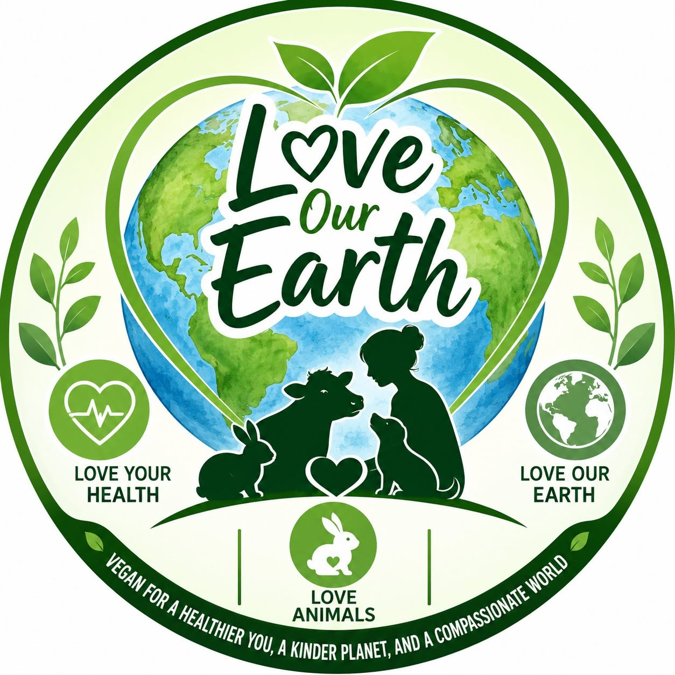

Three Reasons to Choose Vegan.

Vegan for a healthier you, a kinder planet, and a compassionate world
loveourearth.com.au

What if a single daily choice — what you put on your plate — could protect your body, help heal the planet, and spare billions of living creatures from a life of suffering? The case for plant-based diet comes down to three simple ideas: it is good for your health, good for the Earth, and good for the animals we share it with. The evidence is overwhelming, the science is settled, and the change is simpler than you might think.
  Love Your Health |   Love our Earth |   Love Animals

Reason 1 — Love Your Health
Your Body Was Built to Thrive on Plants
A well-planned vegan diet is one of the most powerful tools we have for staying healthy over the long term. Two of the world's leading nutrition bodies agree on this: the British Dietetic Association (BDA) and the American Academy of Nutrition and Dietetics (AND) both recognise well-planned vegan diets as nutritionally complete and health-supporting. The AND's updated 2025 position endorses vegetarian and vegan eating for adults, while the BDA confirms these diets are suitable at every life stage, including pregnancy and childhood.¹
The evidence for disease prevention is strong. A major 2023 review that pooled 76 studies and more than 2 million people found that the more closely people followed a plant-based diet, the lower their risk of type 2 diabetes, heart disease, cancer, and early death.² In a separate study that followed over 100,000 Americans for 30 years, those eating a more sustainable, plant-rich diet had roughly a 25% lower risk of dying from chronic illness than those who ate fewer plants.³
Heart Disease and Blood Pressure
Plant-based eating is especially good for the heart. A review in the journal Nutrients found that vegetarians have a 25% lower risk of dying from ischaemic heart disease — the kind caused by blocked arteries — than non-vegetarians.⁴ It also helps keep blood pressure down: a study of more than 4,100 people in the Journal of Hypertension found vegetarians had a 34% lower risk of high blood pressure than meat-eaters, even after accounting for age, sex, body weight, and factors such as insulin resistance.⁵ Since high blood pressure is one of the biggest risk factors for stroke, this is a compelling reason on its own to eat more plants.
Cancer Protection
The largest study ever conducted on meat-free diets and cancer — led by University of Oxford researchers and drawing on data from 1.8 million people across three continents — found that vegetarians had significantly lower odds of several cancers: 21% lower for pancreatic cancer, 12% lower for prostate, 9% lower for breast, 28% lower for kidney, and 31% lower for multiple myeloma, compared with regular meat-eaters.^{6,7} A separate review found that, overall, a vegan diet is linked to a 7% lower rate of total cancer.⁸
On the meat side of the equation, the World Health Organization's cancer agency (the IARC) classifies processed meat as a Group 1 carcinogen — the same category as tobacco and asbestos. This grouping is based on a review of thousands of studies and reflects how certain scientists are that processed meat causes cancer.⁹
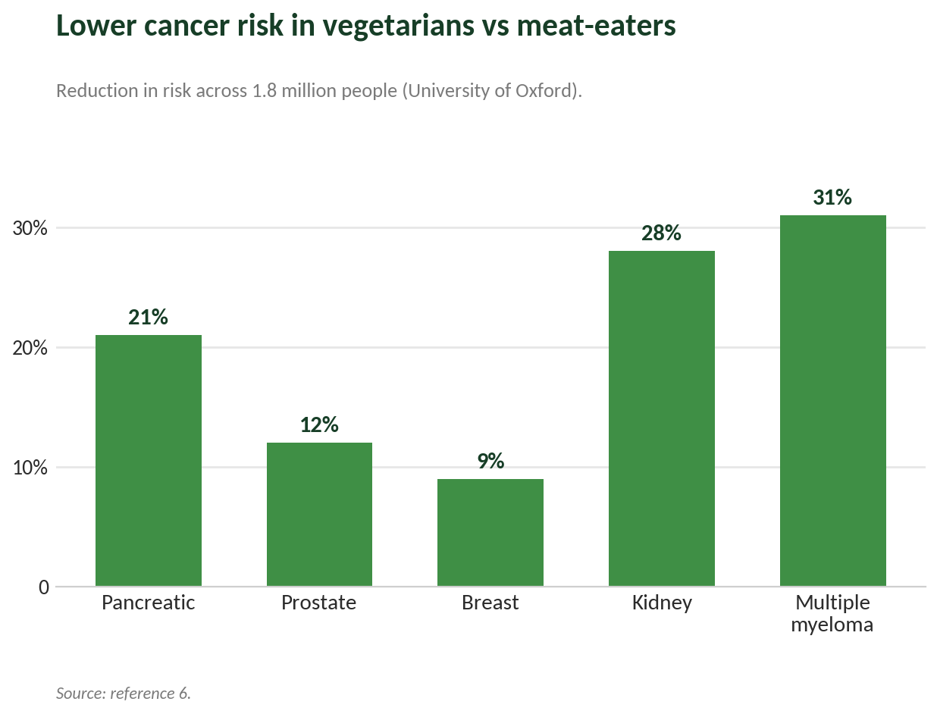
Diabetes
Plant-based diets are also closely tied to lower diabetes risk. In the EPIC-Oxford study, vegans had a 47% lower raw risk of type 2 diabetes than meat-eaters. Much of that advantage shrank once researchers adjusted for body weight — which suggests that staying at a healthy weight, something a plant-based diet makes easier, accounts for a large part of the benefit.¹⁰ Beyond prevention, plant-based diets have been shown to help manage type 2 diabetes and heart disease, and in some clinical settings even to reverse them.¹¹
Weight, Energy, and Everyday Wellbeing
The benefits aren't only long-term — many people feel the difference quickly. In a 2021 survey by The Vegan Society, people who had gone vegan reported real improvements: 56% said their digestion got better, 55% slept better, 53% had more energy, and 52% could walk or run further.¹² A 2025 review of long-term studies backs this up, linking healthy plant-based eating to lower overall and heart-related death rates, and to better health markers — including blood pressure and body weight — than meat-based diets.¹³
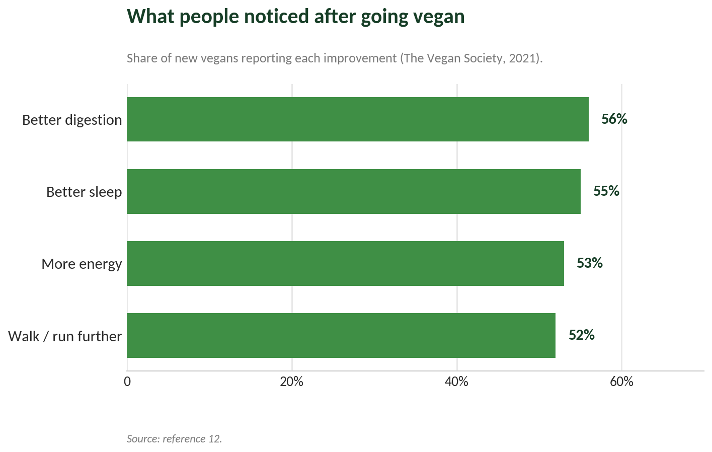
A Healthier Population, a Healthier Budget
The benefits scale up dramatically across a whole population. Analysis by the UK Office of Health Economics, commissioned by The Vegan Society, estimated that if everyone in England switched to a plant-based diet, the National Health Service could save around £6.7 billion a year, prevent 2.1 million cases of disease, and add more than 170,000 years of healthy life.¹⁴
What's Added to the Animals We Eat: Growth Hormones and Antibiotic Resistance
Modern intensive farming leans heavily on chemicals to make animals grow faster and bigger, and that raises real concerns for human health. In Australia, hormonal growth promotants (HGPs) are legal and widely used to help cattle gain weight more efficiently. These are small implants placed under the skin of the animal's ear that slowly release natural and synthetic hormones — including oestrogen-like, testosterone-like, and progesterone-like compounds such as oestradiol and trenbolone acetate — over a period of 100 to 200 days.¹⁵
Antibiotics are another concern. Routinely giving antibiotics to farm animals, both to treat and to prevent illness, is a well-documented driver of antimicrobial resistance (AMR).¹⁶ AMR happens when bacteria evolve to survive the drugs designed to kill them, creating dangerous “superbugs.”¹⁷ These resistant bacteria can reach people in several ways: through direct contact with animals, through contaminated manure, through water and soil, or through eating undercooked meat.¹⁸

How Stress Before Slaughter Affects Meat — and You
In their final hours, farm animals face a barrage of stress — transport, handling, strange surroundings, and extremes of heat or cold — and their bodies respond with a cascade of chemical changes.¹⁹ The animal's stress-response systems pump large amounts of stress hormones, including cortisol and the adrenaline family (adrenaline and noradrenaline), into the bloodstream and muscle.²⁰ One study of Mexican slaughterhouses found that nearly 70% of the cattle examined had severely high blood sugar and sharply raised cortisol at the moment of slaughter.²¹
This stress rapidly burns through the muscle's glycogen (stored energy) reserves. That matters because, after death, glycogen normally turns the muscle slightly acidic — a process that tenderises the meat, slows bacterial growth, and develops flavour.²² Without enough glycogen, the meat can turn out faulty: Dark, Firm, and Dry (DFD) beef, or Pale, Soft, and Exudative (PSE) pork, both of which spoil faster and keep for a shorter time.²³ And the effect may not stop at quality. Leftover stress hormones and the accelerated fat breakdown (oxidation) in such meat may, once eaten, upset the body's balance between harmful and protective molecules, potentially weakening the immune system and contributing to damage to the heart and to cells.²⁴
What About Protein, Iron and B12?
Three of the most common worries about going vegan are easy to put to rest.
On protein: soy foods such as tofu and tempeh are “complete” proteins, meaning they contain all nine essential amino acids on their own. Other plant foods — beans and lentils, whole grains, nuts, and seeds — are each missing some on their own, but eaten across a varied diet they together supply everything the body needs.²⁵
On iron: One of the most common misconceptions about going vegan is that you will end up iron-deficient — but the plant kingdom is full of iron-rich foods. Plant-based iron, known as non-haem iron, is found in a wide range of everyday foods: pulses like lentils, chickpeas and kidney beans; dark leafy greens such as spinach, kale and broccoli; tofu and tempeh; nuts and seeds including cashews, pumpkin seeds and chia seeds; dried fruits like apricots and figs; and wholegrains such as quinoa, oats and wholemeal bread. Many breakfast cereals are also fortified with iron, making it even easier to hit your daily needs. In fact, research shows that people eating a well-balanced plant-based diet are no more likely to develop iron-deficiency anaemia than those on a mixed diet. One simple tip to get the most from these foods: eat them alongside a source of vitamin C — a squeeze of lemon, a handful of cherry tomatoes, or a side of capsicum — as vitamin C significantly boosts the body's absorption of non-haem iron.²⁶
On B12: B12 occur naturally in plant foods such as mushrooms and seaweed. And many of our daily food such as cereals, non-dairy milks, and nutritional yeast are now widely enriched with B12 and easy to work into any meal. What many people don't realise is that the form of B12 used in these fortified foods and supplements — crystalline B12 — is actually better absorbed than the protein-bound form found in meat and dairy. Because it isn't locked inside a food matrix, your body can take it up more readily.²⁷
Why Skipping Fish and Seafood Protects You From Hidden Toxins
Fish / seafood is a major route for harmful contaminants to enter the body. Choosing to skip it helps you avoid:
- Mercury. Eating fish and seafood is one of the main ways people are exposed to mercury. Methylmercury — produced by industrial pollution and by natural processes — builds up as it moves up the food chain, reaching its highest levels in large predatory fish. For pregnant women and young children, this poses a serious risk of damage to the developing brain.²⁸
- “Forever chemicals” (PFAS). PFAS build up in people who eat seafood regularly. A 2024 Dartmouth College study published in the journal Exposure and Health found that people who eat a lot of seafood are exposed to significantly more PFAS than previously estimated.²⁹
- Microplastics. Microplastics turn up in the vast majority of seafood on sale. A peer-reviewed 2025 study found them in 180 of 182 seafood samples taken from retail markets and fishing vessels. These tiny plastic particles are linked to inflammation, oxidative stress, and possible disruption of the body's hormones — and they pass from the fish flesh into your body when you eat it.³⁰
- Antibiotic resistance. Fish farms rely heavily on antibiotics, which creates conditions for drug-resistant infections in people. Crowded aquaculture leaves fish prone to disease, and the well-documented overuse of antibiotics in fish farming feeds the global antimicrobial-resistance crisis — a threat the WHO has identified as one of the greatest risks to public health.^{31,32}

Reason 2 — Love our Earth
Our planet is burning — and your fork can help. Of all the things an individual can do to shrink their environmental footprint, the most powerful is not driving an electric car or flying less — it is changing what they eat. The data here is hard to argue with. Animal agriculture is among the greatest drivers of environmental destruction on the planet. The global food system produces roughly 29.7% of all greenhouse gas emissions, and factory farming is a major part of that.³³ Animal farming on its own — including all the crops grown just to feed livestock — accounts for 57% of food-related greenhouse gases, twice as much as growing all the world's plant foods combined.³⁴
Climate
According to the UN Food and Agriculture Organization (FAO), livestock supply chains alone produce 14.5% of all human-caused greenhouse gas emissions worldwide — about 7.1 gigatonnes of CO₂ every year.³⁵ The wider food system accounts for nearly 30% of global emissions.³⁶ The UN's climate-science body, the IPCC, concluded in its 2022 report on cutting emissions that switching to plant-rich diets is one of the highest-impact actions an individual can take on climate change.³⁷
The potential savings are enormous. Research published in The Lancet projects that a worldwide shift to plant-based diets could cut food-system greenhouse gases by up to 70% by 2050.³⁸ A study of more than 55,000 UK consumers, published in Nature Food, found that vegans have just 30% of the dietary environmental impact of high-meat eaters — making plant-based eating the single most powerful personal climate action available.³⁹ A 2026 analysis posted on EarthArXiv reached a similar conclusion, estimating that going vegan could cut greenhouse gas emissions by up to 61% and land use by up to 60% — the biggest reductions of any dietary change studied.⁴⁰
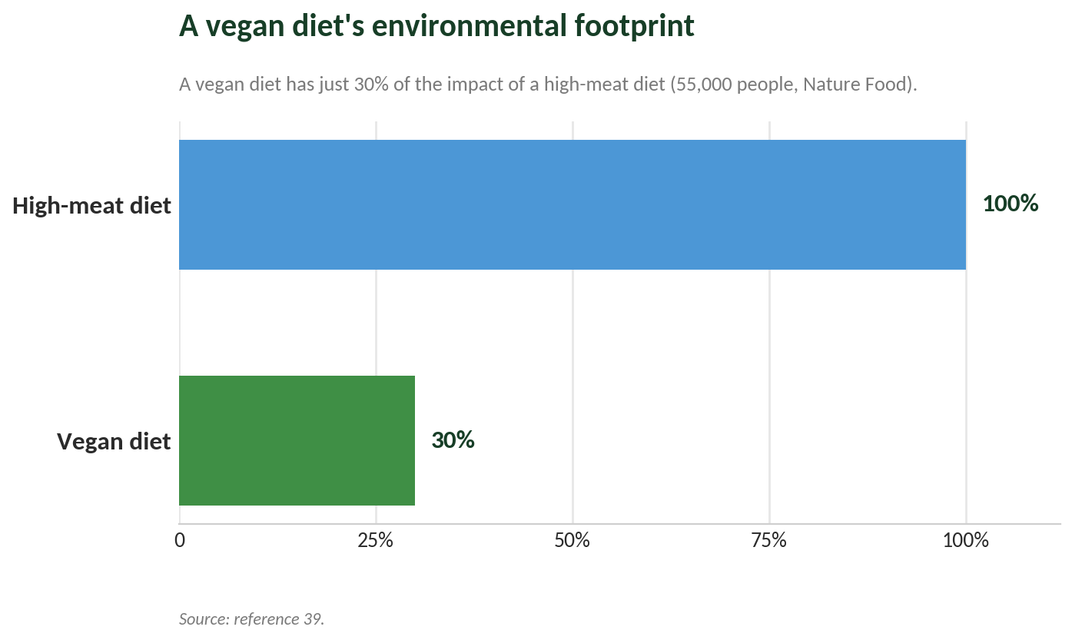
Land and Deforestation
Animal farming is remarkably hungry for land. About 80% of all the world's farmland is used either to graze livestock or to grow their feed — yet it produces only a small fraction of the calories people actually eat.⁴¹ Shifting to plant-based eating could cut the amount of land used to feed each person by up to 76%.⁴²
This land hunger has a direct cost to the world's forests. Animal agriculture — mainly cattle ranching and growing feed crops — is consistently identified as the single biggest driver of Amazon deforestation, responsible for most of the forest clearing in the region.⁴³ The Amazon, the most biodiverse rainforest on Earth, remains under severe pressure from the expansion of cattle operations and soy farming grown to feed animals.⁴⁴
Water
Plant foods are far gentler on the world's water than animal foods. Producing one kilogram of beef takes around 15,400 litres of water,⁴⁵ while one kilogram of lentils takes about 1,250 litres — making lentils roughly 12 times more water-efficient as a source of protein.⁴⁶ Across the board, vegan diets cut the total water footprint more than any other eating pattern studied, with reductions of between 43.8% and 67.4% depending on the population and the type of water measured.⁴⁷ Animal agriculture uses nearly a third of all the fresh water consumed worldwide, much of it for growing feed crops.⁴⁸
The pollution side is just as serious. Excess nitrogen and phosphorus washing off farmland — including from livestock operations and their feed crops — is the main cause of oxygen-starved “dead zones” in the world's oceans, where sea life cannot survive.⁴⁹ Runoff from the US Midwest fuels the largest dead zone in the United States, in the Gulf of America; it covers about 6,500 square miles and returns every summer.⁵⁰ The US Environmental Protection Agency confirms that farm pollution carried down the Mississippi River Basin is the direct cause of this recurring low-oxygen zone.⁵¹
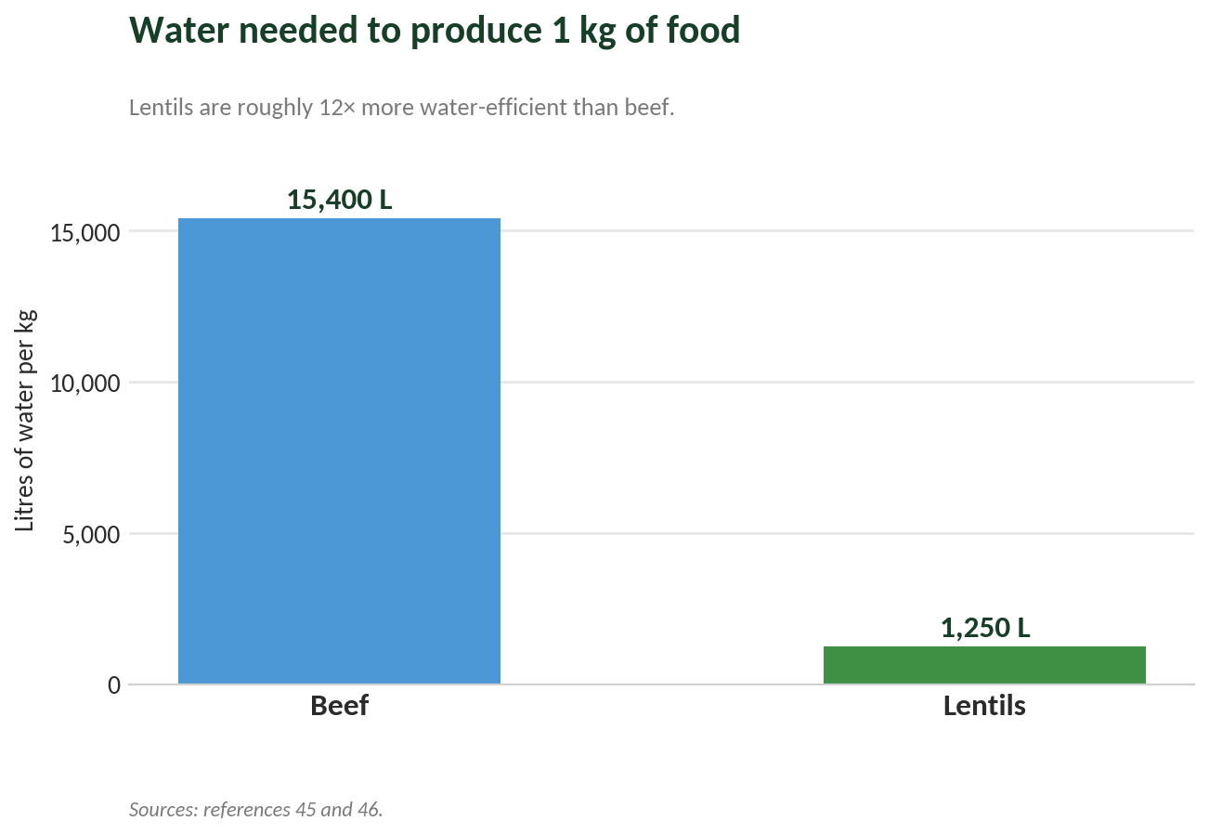
Biodiversity
We are living through a wave of extinctions. Scientists estimate that human activity has pushed the rate at which species disappear to at least 1,000 times the natural background rate that existed before humans had such influence.⁵² The main driver is habitat destruction, and the biggest cause of that worldwide is the spread of agriculture — dominated by animal farming and the crops grown to feed it.⁵³ The UN's 2019 biodiversity report warned that around 1 million animal and plant species are now threatened with extinction, many within decades — more than at any other point in human history.⁵⁴
The Efficiency Argument
There is also a simple efficiency case. Moving away from animal-based foods could add up to 49% to the world's food supply without clearing a single extra acre of cropland.⁵⁵ The water figures make the point starkly: beef needs about 15,400 litres of water per kilogram, compared with roughly 1,250 litres for lentils, showing just how much more efficiently plants turn resources into food at scale.⁵⁶ And a global shift to plant-based diets could reduce food-related greenhouse gases by 70% and cut global deaths by 10% by 2050 — making dietary change not only an environmental priority but a public-health one as well.⁵⁷

Industrial Fishing
It is not only the land that is affected. Industrial fishing is one of the most destructive forces facing the oceans and the climate:
- Overfishing. More than 35% of the world's marine fish stocks are overfished. The FAO's State of World Fisheries and Aquaculture report confirms that 35.4% of marine stocks are fished at biologically unsustainable levels, with most of the rest already pushed to their maximum sustainable limit.⁵⁸
- Bottom trawling. One of the most common and destructive fishing methods, bottom trawling wrecks the seafloor. Heavy weighted nets are dragged along the ocean bottom, destroying fragile habitats such as cold-water corals and sponge beds that took centuries or even thousands of years to form. A 2021 study in Nature estimated that bottom trawling releases as much carbon each year as the entire global aviation industry.⁵⁹
- Bycatch. Industrial fishing causes huge amounts of bycatch — the accidental capture and killing of animals that were not the target. NOAA Fisheries confirms that creatures including dolphins, sea turtles, whales, and seabirds are frequently caught unintentionally, often suffering serious injury or death, which disrupts ocean ecosystems and sets back the recovery of protected species.⁶⁰

Reason 3 — Love Animals
They feel pain. They fear death. They deserve better. For many people, this is the reason they go vegan and never look back — not as a passing diet trend, but as a moral conclusion grounded in science. The animals we eat are not as different from our pets as we have been led to believe. The scientific community now formally recognises farmed animals as sentient beings — able to feel pleasure, fear, pain, and emotional distress.⁶¹
The Scale of Suffering
The numbers are almost too large to picture. Every year, humans slaughter more than 80 billion land animals for food; according to the UN FAO, the reported total reached 83 billion in 2022 alone — a figure that has climbed every year for six decades, and that does not even count the male chicks killed by the egg industry or the many animals for which no data exists.⁶² Once farmed fish are added in, the yearly total likely passes 200 billion and may be far higher — not merely doubling the land-animal figure but dwarfing it.⁶³
A 2026 World Animal Protection Factory Farming Index — the first of its kind — surveyed 151 countries and found that in 2020, 76 billion animals were raised in intensive factory-farming systems worldwide: an average of 10 factory-farmed animals raised and killed for every person on Earth each year.⁶⁴ In the United States, 99.9% of chickens raised for meat spend their entire lives in factory farms.⁶⁵
The Science of Animal Consciousness Is Settled
The question of whether animals are conscious has effectively been answered. In 2012, the Cambridge Declaration on Consciousness — signed by some of the world's leading neuroscientists — formally stated that non-human animals possess the neuroanatomical, neurochemical, and neurophysiological foundations of conscious states, and that humans are not unique in having the neurological basis for consciousness.⁶⁶ In 2024, the New York Declaration on Animal Consciousness — led by scholars from New York University, York University, and the London School of Economics — went further, affirming “strong scientific support” for consciousness in all mammals and birds, and “at least a realistic possibility” of conscious experience in all vertebrates, including fish, and in many invertebrates.⁶⁷ Animals feel pain. Animals feel fear. Pigs, cows, chickens, and fish are not objects; they are individuals living their own lives.
Animal Intelligence and Emotions
These animals are also far smarter and more emotional than most of us realise. As the renowned scientist Jane Goodall has put it: “Farm animals feel pleasure and sadness, excitement and resentment, depression, fear and pain. They are far more aware and intelligent than we ever imagined.” The research bears her out. Studies have shown that pigs can solve mazes, use mirrors to find hidden treats, and even play simple video games.^{68,69} A peer-reviewed study in Animal Cognition found that chickens can plan ahead, grasp cause and effect, and exercise self-control — abilities we usually associate with much larger-brained animals.⁷⁰ And Cambridge University researchers found that cows have “eureka” moments, taking genuine pleasure in working something out, while also forming deep social bonds and recognising one another's faces.⁷¹
The Reality of Factory Farms
Most farmed animals never get to live anything resembling a natural life. In factory farms they live only a fraction of their natural lifespan, in bare, crowded conditions with almost no chance to do the things that come naturally to them — socialising, raising their young, or simply exploring. The human cost is real too: the factory farming of chickens, pigs, and cows is calculated to take an average of 1.8 years of healthy life from every person on Earth, through antibiotic resistance, respiratory disease, and excess meat consumption.⁷² Researchers have demonstrated empathy in pigs, social intelligence in goats comparable to that of dogs, and even the ability to potty-train cows — and yet these animals receive none of the protections we extend to the pets we love.
Inside the Industry, Animal by Animal
The everyday conditions on factory farms are difficult to defend once you know the details.
- Meat chickens — over 99.9% factory-farmed. According to the Sentience Institute, more than 99.9% of chickens raised for meat in the US live on factory farms.⁷³ In intensive UK systems, the RSPCA reports that these birds are typically slaughtered at around five weeks old, weighing about 2.2 kg, after gaining more than 62 g a day; in the US, the standard range is 7 to 9 weeks for most commercial broilers.⁷⁴ Either way, the core welfare concern is the same: they have been selectively bred to grow so fast that many can no longer support their own weight, leaving them lame and suffering before slaughter.⁷⁵
- Egg-laying hens — 98.3% factory-farmed. The Sentience Institute reports that 98.3% of egg-laying hens in the US are kept in factory-farm conditions.⁷⁶ Hens in battery cages are typically given around 750 cm² of space each — barely larger than a sheet of A4 paper (624 cm²) — leaving no room to spread their wings, dust-bathe, perch, or nest.⁷⁷
- Pigs — 98.6% factory-farmed. The Sentience Institute reports that 98.6% of pigs in the US are raised on factory farms.⁷⁸ Breeding sows are confined in individual metal gestation crates about 2 feet wide by 7 feet long throughout their four-month pregnancies — crates so small the animal cannot turn around.⁷⁹ Shortly before giving birth, sows are moved into equally restrictive farrowing crates, where they can be confined for up to five weeks at a time, several times a year.⁸⁰
- Turkeys — 99.8% factory-farmed. The Sentience Institute reports that 99.8% of turkeys in the US are factory-farmed, confined from the moment they hatch.⁸¹ They are hatched in large incubators, never meet their mothers, and within a few weeks are packed into filthy, windowless sheds with thousands of other birds for the rest of their short lives.⁸² Like meat chickens, they have been selectively bred and genetically manipulated to grow so large so fast that many become crippled under their own weight or die of heart failure before reaching slaughter age.⁸³
- Dairy cows — calves taken at birth. In Australia, the standard practice is to separate calves from their mothers within the first few hours of birth, on grounds of biosecurity and disease prevention.⁸⁴ Worldwide, 97% of newborn dairy calves are forcibly removed from their mothers within the first 24 hours.⁸⁵ Because a cow only produces milk after giving birth, dairy cows are kept almost continually pregnant throughout their productive lives — and male calves, of no value to the dairy industry, are typically slaughtered within their first week.⁸⁶
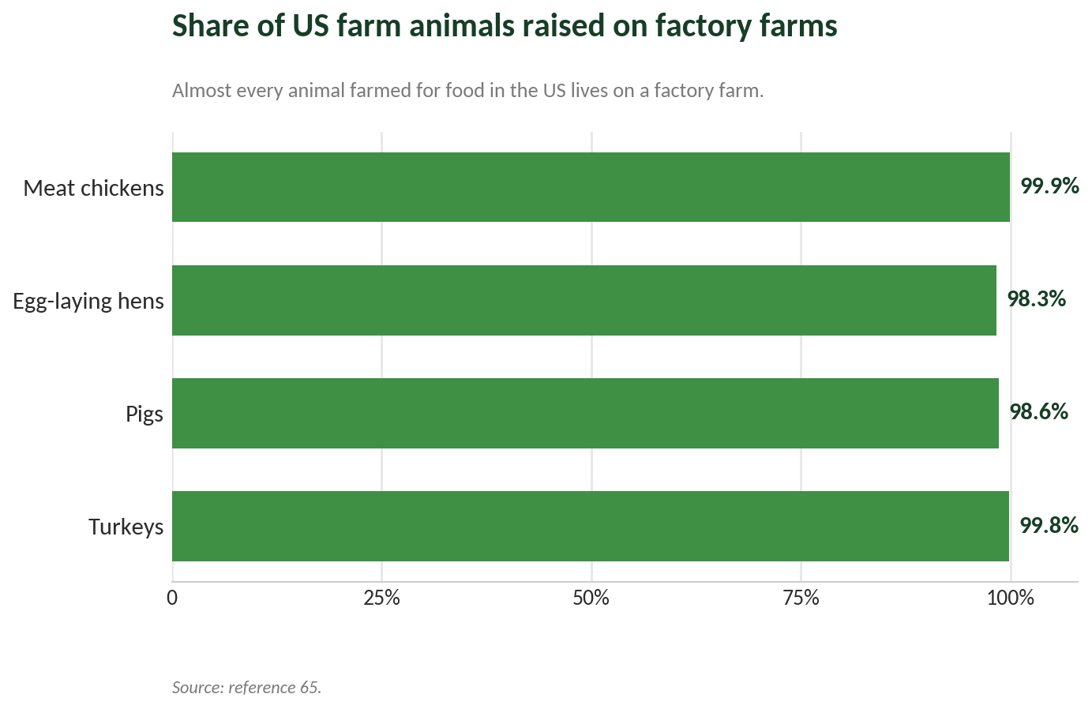
Fish Feel Pain Too
It is easy to leave fish out of the picture, but the science says we should not. Every piece of seafood comes at a cost that science can no longer ignore:
- Fish are sentient and can suffer. A landmark review published in Animal Sentience concluded that there is substantial empirical evidence that fish experience pain (nociception) and likely have conscious experiences of it. Work by Professor Lynne Sneddon documented pain receptors in fish, along with behaviour consistent with genuine suffering.⁸⁷
- Hooks cause real pain and injury. Among fish thrown back after catch-and-release fishing, a meaningful proportion die from their injuries or from physiological stress, and some survivors are left with impaired sensory function. The harm done by hook fishing is well documented across many species and fishing contexts.⁸⁸
- Deep-water fish suffer barotrauma. These are catastrophic internal injuries caused by the rapid pressure change as fish are hauled up to the surface. Despite all this, fish have long been excluded from animal-welfare laws in most countries, based on outdated assumptions about their capacity for suffering — assumptions that a growing body of peer-reviewed science has now firmly overturned.⁸⁹
Closing: The Choice That Changes Everything
Love your health — because a plant-based diet protects your heart, reduces cancer risk, and gives your body what it was always meant to thrive on.
Love our Earth — because the rainforests, water cycles, and biodiversity that sustain all life need us to eat differently, and the science shows individual dietary choices scale into enormous collective impact.
Love animals — because they feel, because they suffer, and because if we saw what is done to them in our name, most of us would say: not like this, not for me, not anymore.
Every meal is a choice. Every choice is a vote for the world you want to live in. Go vegan.
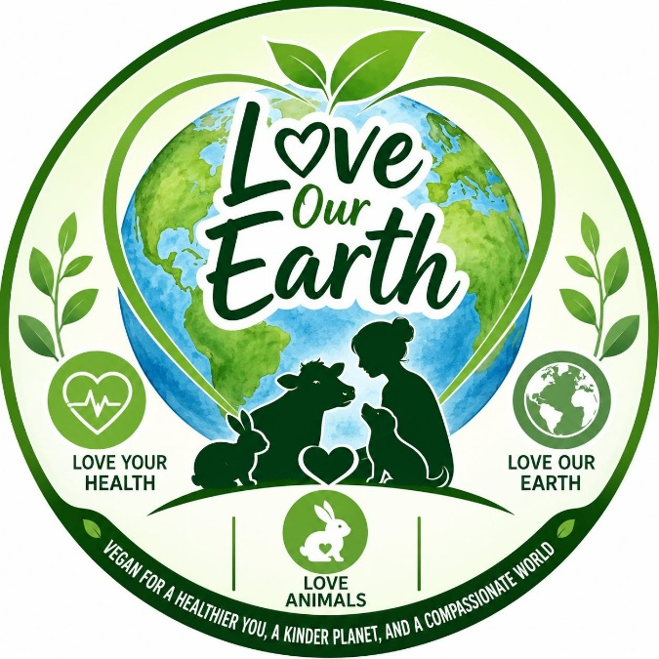
Vegan for a healthier you, a kinder planet, and a compassionate world
loveourearth.com.au

References
Sources are numbered in the order they appear in the document.
1. https://www.eatrightpro.org/news-center/research-briefs/new-position-paper-on-vegetarian-and-vegan-diets
2. https://www.scribd.com/document/945539044/12937-2023-Article-877
3. https://news.sky.com/story/planet-friendly-diet-could-reduce-risk-of-death-from-chronic-illness-by-25-study-finds-12926098
4. https://pmc.ncbi.nlm.nih.gov/articles/PMC10548188/
5. https://pubmed.ncbi.nlm.nih.gov/27512965/
6. https://www.wcrf.org/about-us/news-and-blogs/largest-ever-study-of-vegetarian-diets-and-cancer-shows-lower-risk-of-5-cancers/
7. https://www.medsci.ox.ac.uk/news/largest-study-of-vegetarian-diets-and-cancer-shows-lower-risk-of-five-cancers
8. https://jamanetwork.com/journals/jamanetworkopen/fullarticle/2802814
9. https://www.who.int/news-room/questions-and-answers/item/cancer-carcinogenicity-of-the-consumption-of-red-meat-and-processed-meat
10. https://pmc.ncbi.nlm.nih.gov/articles/PMC7613518/
11. https://www.vrg.org/blog/2022/11/18/vegan-diets-and-long-term-health-what-weve-learned-from-the-epic-oxford-study/
12. https://www.vegansociety.com/news/media/statistics/health
13. https://www.frontiersin.org/journals/nutrition/articles/10.3389/fnut.2025.1518519/full
14. https://www.ohe.org/news/a-switch-to-vegan-diets-could-save-the-nhs-6-7-billion-per-year-new-research-reveals/
15. https://www.goodmeat.com.au/animal-health-welfare/hormone-use/
16. https://www.ncbi.nlm.nih.gov/pmc/articles/PMC12029767/
17. https://www.who.int/news-room/fact-sheets/detail/antimicrobial-resistance
18. https://nam.edu/perspectives/antibiotic-resistance-in-humans-and-animals/
19. https://pubmed.ncbi.nlm.nih.gov/22443909/
20. https://www.sciencedirect.com/science/article/abs/pii/S0309174004002736
21. https://pubmed.ncbi.nlm.nih.gov/32054158/
22. https://www.sciencedirect.com/science/article/abs/pii/S1871141322002475
23.https://acikders.ankara.edu.tr/pluginfile.php/107929/mod_resource/content/0/4.%20Ders%20PSE%20%20DFD%20MEAT.pptx
24. https://pmc.ncbi.nlm.nih.gov/articles/PMC7402184/
25. https://health.clevelandclinic.org/do-i-need-to-worry-about-eating-complete-proteins
26. https://www.nhs.uk/live-well/eat-well/how-to-eat-a-balanced-diet/the-vegan-diet/
27. https://www.forksoverknives.com/wellness/vitamin-b12-questions-answered-2/
28. https://www.epa.gov/mercury/how-people-are-exposed-mercury
29. https://home.dartmouth.edu/news/2024/04/pfas-exposure-high-seafood-diets-may-be-underestimated
30. https://www.theguardian.com/us-news/2025/feb/03/seafood-microplastic-contamination-study
31. https://www.fao.org/antimicrobial-resistance/key-sectors/fishery-and-aquaculture/en/
32. https://pmc.ncbi.nlm.nih.gov/articles/PMC8198758/
33. https://www.fao.org/statistics/highlights-archive/highlights-detail/greenhouse-gas-emissions-from-agrifood-systems.-global--regional-and-country-trends-2000-2022
34. https://www.pcrm.org/good-nutrition/vegan-diet-environment
35. https://openknowledge.fao.org/items/5e54916e-a037-4b05-b04a-a46e87ffbe72
36. https://www.fao.org/statistics/highlights-archive/highlights-detail/greenhouse-gas-emissions-from-agrifood-systems.-global--regional-and-country-trends-2000-2022
37. https://www.pcrm.org/good-nutrition/vegan-diet-environment
38. https://www.pcrm.org/good-nutrition/vegan-diet-environment
39. https://www.medsci.ox.ac.uk/news/vegan-diet-has-just-30-of-the-environmental-impact-of-a-high-meat-diet-major-study-finds
40. https://eartharxiv.org/repository/view/11342/
41. https://www.humaneworld.org/en/news/eight-reasons-eat-plant-based-and-save
42. https://pmc.ncbi.nlm.nih.gov/articles/PMC9024616/
43. https://earth.org/how-animal-agriculture-is-accelerating-global-deforestation/
44. https://en.wikipedia.org/wiki/Deforestation_of_the_Amazon_rainforest
45. https://www.thecattlesite.com/news/49594/how-much-water-does-it-take-to-produce-meat/
46. https://bitekit.app/tools/food-water-footprint-calculator/
47. https://pmc.ncbi.nlm.nih.gov/articles/PMC7551173/
48. https://www.humaneworld.org/en/news/eight-reasons-eat-plant-based-and-save
49. https://www.epa.gov/nutrientpollution/effects-dead-zones-and-harmful-algal-blooms
50. https://www.fluencecorp.com/agricultural-runoff-fuels-gulf-dead-zones/
51. https://www.epa.gov/nutrientpollution/effects-dead-zones-and-harmful-algal-blooms
52. https://www.pbs.org/newshour/science/animal-extinctions
53. https://www.un.org/sustainabledevelopment/blog/2019/05/nature-decline-unprecedented-report/
54. https://www.un.org/sustainabledevelopment/blog/2019/05/nature-decline-unprecedented-report/
55. https://sustain.ucla.edu/food-systems/the-case-for-plant-based/
56. https://www.thecattlesite.com/news/49594/how-much-water-does-it-take-to-produce-meat/
57. https://www.pcrm.org/good-nutrition/vegan-diet-environment
58. https://www.fao.org/documents/card/en/c/cc0461en
59. https://www.nature.com/articles/s41558-021-01062-9
60. https://www.fisheries.noaa.gov/insight/understanding-bycatch
61. https://onlinelibrary.wiley.com/doi/full/10.1002/aro2.65
62. https://ourworldindata.org/data-insights/billions-of-chickens-ducks-and-pigs-are-slaughtered-for-meat-every-year
63. https://pmc.ncbi.nlm.nih.gov/articles/PMC10936281/
64. https://www.worldanimalprotection.ca/our-work/reports-library/factory-farming-index
65. https://www.sentienceinstitute.org/us-factory-farming-estimates
66. https://fcmconference.org/img/CambridgeDeclarationOnConsciousness.pdf
67. https://sites.google.com/nyu.edu/nydeclaration/declaration
68. https://www.frontiersin.org/news/2021/02/11/frontiers-psychology-domestic-pigs-remarkably-intelligent-can-learn-play-video-games
69. https://pmc.ncbi.nlm.nih.gov/articles/PMC7928376/
70. https://pmc.ncbi.nlm.nih.gov/articles/PMC5306232/
71. https://edgarsmission.org.au/eureka/
72. https://www.worldanimalprotection.ca/our-work/reports-library/factory-farming-index
73. https://www.sentienceinstitute.org/us-factory-farming-estimates
74. https://www.rspca.org.uk/documents/1494939/7712578/FAD-Meat-Chickens-Information-Sheet-2022.pdf
75. https://www.aspca.org/protecting-farm-animals/animals-factory-farms
76. https://www.sentienceinstitute.org/us-factory-farming-estimates
77. https://ourworldindata.org/do-better-cages-or-cage-free-environments-really-improve-the-lives-of-hens
78. https://www.sentienceinstitute.org/us-factory-farming-estimates
79. https://www.humaneworld.org/en/what-are-gestation-crates
80. https://thehumaneleague.org/article/pig-gestation-crates
81. https://www.sentienceinstitute.org/us-factory-farming-estimates
82. https://www.peta.org/issues/animals-used-for-food/factory-farming/turkeys/turkey-industry/
83. https://www.farmtransparency.org/kb/food/turkeys
84. https://www.dairy.com.au/you-ask-we-answer/how-long-do-dairy-calves-stay-with-their-mothers-and-why-are-they-separated
85. https://www.facebook.com/thehumaneleague/posts/cows-need-to-give-birth-in-order-to-produce-milk-just-like-humans-so-the-dairy-i/
86. https://animalsaustralia.org/our-work/farmed-animals/what-happens-to-dairy-calves/
87. https://www.wellbeingintlstudiesrepository.org/animsent/vol3/iss21/17/
88. https://www.ncbi.nlm.nih.gov/pmc/articles/PMC6920254/
89. https://www.cjccl.ca/wp-content/uploads/2020/11/Cassuto-OBrien.pdf

